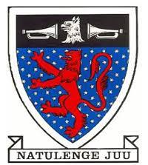

STAREHE BOYS’ 2025 PREDICTION
Kenya Certificate of Secondary Education
ANTICIPATED KCSE EXAM
231/3 Biology Paper 3

SCHOOL……………………………………………… SIGN…………………………..

PRACTICAL CONFIDENTIAL
Each Candidate Requires The Following:
- About 5g(small)piece of specimen Y.
- 4 test tubes in a test tube rack and 2 droppers.
- 10ml of 20% hydrogen peroxide solution in a test tube.
- 100ml empty beaker – 2.
- 10ml measuring cylinder.
- A pair of forceps.
- Access to hot water maintained at 80°C from a hot water bath.
- 2 wooden splints.
- (1 ripe orange fruit labeled specimen K).
- Scalpel.
- Access to:
- Sodium hydroxide solution - 4ml per candidate.
- Copper (II) sulphate solution - 2ml per candidate.
- Dilute hydrochloric acid - 2ml per candidate.
- Sodium hydrogen carbonate solution - 2ml per candidate.
- Benedict's solution - 4ml per candidate.
- Source of heat.
Note:
- 5g (small) piece of fresh liver labeled as specimen Y.
- 1 ripe orange fruit labeled specimen K.

